9050PROJ Project AQF Level 9
Dylan Thomas
A002281936

Starting with Agility: Building ‘Sense’ and ‘Seize’ Before Doing Anything

Entrepreneurial Management

Growing an Entrepreneurial Venture

Word count: 550 words [Max 500]

Executive summary
[… type text here …]

Table of contents
[update the ToC by right-clicking on the ToC and selecting Update field] [ TOC not included in the word count]
Executive summary 1
1 Introduction (600 words) 3
2 Review of theories and frameworks 5
2.1 Business theories 5
2.2 Analytical frameworks 6
3.1 Case study research 9
3.2 Secondary data 9
3.3 Analytical frameworks (method or tool) 10
4 Analysis and findings 12
5 Discussion and implications 12
6 Recommendations 12
7 Conclusions 12
References 13
Appendix 1 – Project Reference Map 15
Appendix 2 – Figures 18

Introduction (600 words)

The entrepreneurship domain is undergoing a disruptive digital transformation, presenting unique opportunities and challenges that have significant strategic or performance benefits shaping high-performing venture environments. The dominant player in this disruption is Artificial Intelligence (AI) and Machine Learning (ML), individually these tools help shape light and agile development teams, but when combined they create potent recipes for semi-supervised or fully autonomous systems capable of continuous learning, adaptiation, and efficient big data processing. The proximity to the data source reduces delay when these systems communicate improving the firms ‘sense’ of their environment, while enhancing the efficiency of decision-making pipelines integrated with advanced systems such as DevOps, MLOps, and AIOps integrations, creating conditions to ‘seize’ an opportunity and further benefitting their self-learning potential (Teece et al., 1997). As Kubr (2002) proposed, knowledge in entrepreneurial domains is becoming recognised as a fundamental source of value generation in new ventures.

For example, interacting with a ChatGPT-4 model for QnA seems neat, until one realises it has limited interaction outside of its own environment, so it doesn’t perform goal-oriented tasks. But what if you had one GPT-4 model, and you had automated DevOps AI teams with 10 – 20 agents running inferences off the GPT language model and each time they executed a run, they were writing/reading little training cycles to the LLMs ‘experience’ and so the GPT model became accustomed to being this large corpus of language as a datastore for orchestrating Autonomous AI agents and this pipeline was self-hosted (Wang et al., 2024). Then according to Kubr (2002), you may be running a valuable synthetic knowledge source or you might be running an enterprise. The blending of creativity and self-agency is what this author believes is likely to drastically change what communities of individuals will be able to do to augment their daily lives in digital spaces. This is the opportunity that is being recognised. However, the tech industry will have to grow its capabilities significantly more to produce an environment to create that possibility for an end consumer or a community.

The purpose of this research primarily focuses on evaluating primary growth drivers and technologies that enable growth in in new ventures that target sustainable competitive advantage, such as technological competencies that include AI, ML, data-analytics and platformisation to support or enhance the venture creation processes for SMEs. Whether its to reduce barriers of entry and increase the diversity of individuals or teams who can access and participante in the venture creation process, or for those who aim for agile and high-performance settings in their development environments and their build-measure-learn feedback loop (Savarese et al., 2016). A recent report from IBISWorld in 24’ stated that the Global Management Consulting industry generated roughly $1 trillion in revenue between 2019 and 2024, with anticipated growth rate of 0.6% from ’24 to ’29 (Appendix 2 – Figure 1) (Ristoff, 2024). In this GMC industry the number of firms spike 8.9%, with a majority of them being two members (i.e. partnerships), and an expected 4.6% growth in new firms over the next reporting period and there is noticeable expansion in the industry (Appendix 2 – Figure 2), which includes the ‘Other’ GMC services group that comprises 28% of this cohort and includes Knowledge Management consultants.

Several paradigm shifts in markets are driving this growth cycle, with Cloud deployments, AI, ML and big data analytics services predicted to drive firm performance in 2024 (Ristoff, 2024). Savarese et al. (2016) conducted a study on high-growth Italian tech firms supporting this trend with acquiring new technologency competencies and access to external knowledge systems contributing to the orchestration of this new venture success, while resource utilisation may be handled by machines but is controlled by managers according to the Dynamic Capability Framework (Augier and Teece, 2009). However, barriers to successful entrepreneurial ventures remain, between 2021 – 2023 a Jetbrains (2023) survey found no meaningful change in developer gender representation, with 95% male and 5% female, potentially limiting the benefits of observational learning from ‘spans’ of activity in Entrepreneurial Ecosystem networks (Anderson et al., 2010). A secondary purpose of this exploratory case study is to apply open-source adaptations of the Dynamic Capabilities Framework (Teece, 2007), which provides a theoretical foundation to assess how firms efficiently integrate, build and reconfigure competencies to seize opportunities, such as the digital transition. Furthermore, Microfoundations (Teece, 2014, Bojesson and Fundin, 2021) are also examined due to their roles as enablers of dynamic capabilities, hence this report serves the dual purpose of aiming to translate into actionable strategy for ModifyMe, a nascent SME at the edge of digital innovation.

This study wil adopt a single case study methodology where the startup ‘ModifyMe’ will be compared to the industry

Review of theories and frameworks
This section examines a pairing of two complementary business theories and two business analytical frameworks that guide the strategic direction of technological competencies. Here, Open Innovation Systems theory, the Knowledge-Based View as an extended RBV (RBV KBV), the Dynamic Capabilities Framework and the VRIO.

Business theories
ModifyMe is in the nascent startup stage and is exploring opportunities to enhance its dynamic capabilities via technological competencies to achieve sustainable competitive advantage. Two foundational business theories were chosen for their relevance to the business opportunity: Open Innovation theory (Chesbrough, 2003) and Knowledge-Based Value of the Firm (KBV) (Grant, 1996), they were chosen for their capacity to foster the desired environment to develop dynamic technological capacities for ModifyMe, a nascent startup at the edge of digital transition, as it desires integration with automation, AI+ML and serverless platform architectures to acquire an agile, capable and competitive market position in the knowledge management industry.

2.1.1 Open Innovation (OI) (Chesbrough, 2003):
Open Innovation leverages both internal and external ideas via knowledge corridors to produce innovation that facilitates technological advancement and achieve market success (Chesbrough, 2003). This theory supports advancing ModifyMe’s capabilities from applying with open-source frameworks and projects to access external knowledge pools/pathways. This is reflects the benefits of collaborative development environment and establishing co-creation habits that enhance dynamic capabilities in the technology sector (Chesbrough, 2003). OI is beneficial for studying entrepreneurs from the perspective of bricolage (i.e. iterative testing-retesting and prototyping) and explains how entrepreneurs in new ventures can travel through multiple environments and manage restricted resources innovatively (Baker et al., 2005, Santoso et al., 2020, Prijadi et al., 2023). Important for understanding how tech start-up SME’s like ModifyMe adopt strategies for open innovation strategies to interact with external technologies and knowledge bases to overcome limited resource pools and create value. Open Innovtion System theory supports ModifyMe’s interest in adopting open-source frameworks and is an important first step for a new entrent in the Open Source ecosystem, as it establishes co-creation habits early in their experimentation .

- Knowledge-Based View (KBV) of the firm (Grant, 1996):
First, the RBV (Barney, 1991) emphasises the significance of a firm’s internal resources as a source of competitive advantage, proposing them as valuable, rare, inimitable and non-substitutable in contrast to the firm's external environment (Barney, 1999). However, the KBV further extends the RBV by proposing that the strategic management of a firm's internal knowledge resources supports a firm’s competitive advantage (Grant, 1996). These theories complement knowledge-based domains and further support applying Knowledge Engineering (KE) principles for configuring a firms internal and external capabilities, supporting a sustainable advantage. This theory is highly relevant to ModifyMe as its operations and services are in a knowledge-intesntive field of cloud and AI computing. In organisations, Knowledge Engineering (KE) refers to the technologies and practices that define, structure, represent and disseminate knowledge in complex systems that support Big Data processing (Chalmers et al., 2020). The process of continual knowledge refinement and deployment can be facilitated by Symbolic Knowledge Distribution (West et al., 2021).

In summary, the KBV and Open Innovation Systems theory form a robust theoretical canon to apply to analytical tools for testing the firms dynamic capability development in pursuit of its opportunity.

Analytical frameworks
This section presents an examination of two foundational business analytical frameworks: the Dynamic Capabilities Framework (Teece, 2007) and the VRIO Framework (Barney, 1991) and aims to describe their role for ModifyMe, a nascent startup at the edge of digital transition, as it desires integration with automation, AI+ML and serverless platform architectures to secure an agile, capable and competitive position in the market.

A. Dynamic Capabilities Framework (Teece, 2020, Teece et al., 1997):
The Dynamic Capabilities Framework proposes that the essence of competitive advantage is dependent on a SME’s “sense”, “seize”, “reconfiguring” and “learning and integration” functions, and helps to understanding how new firms navigate volatile markets like knowledge-based industries by adapting, integrating, and reconfiguring internal/external competencies (Teece, 2007). This framework suggests that firms operating in technology-based industries should adopt lean and agile principles to respond to technological advancements in the marketplace and sustain success (Teece, 2020). ModifyMe’s research into AI and ML deployments across Edge Networks and IoT for Big Data processing represents this continual adaptation to market conditions, with the implementation of a cloud Supabase database capable of advanced hybrid retrieval of coding repositories at any Edge node to optimise internal/external alignment with external market conditions (Hamdan et al., 2023). Similarly, Wang and Ahmed (2007) propose that agility and flexibility of deployment with dynamic capabilities are important features of an effective strategy.

- VRIO Framework (Barney, 1991):
The VRIO framework provides an assessment of a firm’s resources as either valuable, rare imitable, and organisation, which determines if they can be a source of sustainable value (Barney, 1991). Concentrates on exploiting external opportunities from leverage gained from internal resources, it directly reflects a relationship with the Dynamic Capabilities Framework (Eisenhardt and Martin, 2017). It reflects a synergy with Dynamic Capabilities in utilize a firms internal environment to exploit external opportunities. For ModifyMe, VRIO can help prioritse multiple open source projects to direct human capital where it matters most.

This section is comprised of a three-pronged approach, comprised of a case study research methodology, the specific secondary data used in the analysis and the selected analytical tool used to assess the data. The integration of these three components provides a robust a reliable methodology to investigate ModifyMe’s pursuits in serverless platform and microservices (Saunders et al., 2019).

Case study research
This research employs a single case study to exploring how a new firms navigate the integration of advanced technological capabilities within their organisational and strategic frameworks. A single case study design is especially suited for this case study research methodology (Yin, 2018). Specifically, this study design presents an opportunity to investigate the alignment of theory with emerging practical implementations of firms gaining competitive advantage from the Dynamic Capabilities Framework (Teece et al., 1997) and incorporate principles with Open Innovation (Chesbrough, 2003) and platformization strategies which involves applying academic and industry research towards a single firm (ModifyMe). By comparing ModifyMe to existing academic and industry literature supports the method used in this study by positioning the nascent firm (ModifyMe) in the wider practical landscape, reflecting an environmental ‘scan’ according to the Dynamic Capability framework (Teece, 2007, Baxter and Jack, 2008). This helps build the firms ‘micro-foundations”, which refer to the managerial skills that contribute to firm performance (Gerhart and Feng, 2021).

Secondary data
A literature review of secondary data will guide the exploratory orientation of this hypothetical new venture (Zhang et al., 2017). Secondary data sources are included in Table 1 below.
Data | References
Industry Report | - IBISWorld Global Management Consultants L6712-GL (Ristoff, 2024)  - Chesbrough (2003) - Supply empirical benchmarks for open innovation and platformization strategies
Quantitative | - Publicly available statistics (e.g. IMF, OECD, publicly available governmental data)’  - ublic databases and scholarly articles furnish both macro and micro-level insights into market demands, technological advancements, and innovation practices that are pertinent to ModifyMe’s operational strategies.
 | - Kaggle datasets (197k in dataset assets) (Roman et al., 2023)
 | - Google Dataset Search
Qualitative – Scoped in () | - Journal Articles (Narrow)
 | - Literature Reviews (Focused)
 | - Meta-analyses (Broad)
Github | - 802 million files/ 11.3 million repos in data assets
 | - 9 million (1.1%) ‘Open Data’ licences
 | - 609 million (75%) No licences
Academic Literature | - Eisenhardt and Martin (2017) provide a theoretical background of the Dynamic Capabilities Framework – Helps guide core mechanisms which firms like ModifyMe can use to maintain agility and sustainable competitive advantage in volatile technological ecosystems.
Source: Created by Student for Assessment.

Table 2: Resource-Based Framework Comparison for Case Study
Resource-Based Theoretical Frameworks :
Porter’s (1985)  Porter’s Five Forces | Barney (1991)  Resource-Based View (RBV) | Teece (2020)  Dynamic Capabilities Framework (DC)
- attention on external industry structures to internal resources | - attention on external industry structures to internal resources  - RBV’s emphasis on unique internal resources reflects a market shift towards firm-specific factors in achieving competitive advantage. | - characterises the agility and flexibility,  - acknowledging competitive advantage translates to the firm’s ability to adapt and renew resources in alignment with shifting market trends, not the resources themselves.
Wider Community Shifting Managerial Preferences:

- Moving from a Porter’s Five Forces iterative development process to a static state external resource to an internal external focus with RBV.
- an active internal/external pro-active orchestration with the Dynamic Capabilities Framework
- This trajectory reflects deep integration with internal management behaviours, strategic foresight, and a broader economic and technological landscape affecting firms (Teece, 2007, Teece et al., 1997)

Source: Created by Student for this assessment.

Case Study Methodology

Porters Five Forces was introduced as a strategic tool to analyze industrial attractiveness and competitive intensity from an external viewpoint. Porter’s Five identifies five market forces that influence the threat to profitability, potential entrants, suppliers, buyers, substitutes, and industry rivalry (Porter, 2008). However, Porter’s model has been critiqued for its static nature and limited consideration to innovation and changing industry dynamics (Augier and Teece, 2009). The tool does not examine internal firm attributes and managerial capability, rather it focuses on market positioning and external competitive forces. Thus, it is less adaptable to dynamic environments (i.e. tech) where industry rules and competitors evolve (Teece, 2007).

The Resource-Based View transitioned Porter’s Five Forces industry-level analysis to firm-level analysis of internal resources as sources of sustainable competitive advantage if they possess unique, inimitable, resources (Barney, 1991). The RBV takes into account internal organisational components, assuming a company’s unique resources and capabilities drive sustained competitive advantage. The RBV has been integrated into the broader discussion of capabilities and has been associated with the Dynamic Capabilities. However, RBV has the limitation of adopting a static approach and unfocused market perspective of how firms sustain competitiveness in evolving markets (López Rodríguez and García Rodríguez, 2005).

The Dynamic Capabilities Framework extends RBV and overcomes the static issues with the two previous frameworks because it characterises a firms ability to sense and seize opportunities, shape them with continuous learning, and maintain competitiveness through strategic reconfiguration of internal and external competencies (Teece, 2007). Dynamic capabilities are defined as the capacity to adapt and reconfigure internal and external competencies in response to changing volatile environments (Teece et al., 1997, Augier and Teece, 2009).

Hence, the Dynamic Capabilities Framework is selected as the analytical tool for the case study because it is a sufficient ‘fit’ with how organisations evolve ‘embedded relationships’ with their resources to respond to rapid changes in market conditions, which is especially relevant for SMEs. This framework’s adaptability, with its 4 dimensions, results in it being an ideal tool for the task (Teece, 2007, Teece et al., 1997).

Analysis and findings
EDIT EDIT EDIT Zahra et al. (2006) further clarify dynamic capabilities by emphasizing their role in creating strategic heterogeneity between new ventures and established firms, highlighting the importance of dynamic capabilities in both contexts. EDIT EDIT EDIT

Applying the Dynamic Capability Framework:
- Sensing Capabilities and Technological Adoption (250 words)
Sensing capabilities have a central role in identifying technological opportunities that SMEs can leverage to gain competitive advantage (Teece, 2007). Furrther, some studies

- Seizing Opportunities through Platform Capabilities

- Reconfiguring Operations with Automation and AI Technologies

- Learning and Innovation through Integration Capabilities
d

Discussion and implications
[… type paragraphs here…]

Recommendations
[… type paragraphs here…]

Conclusions
[… type paragraphs here…]

References

The state of developer ecosystem in 2023 infographic (2023) JetBrains. Available at: https://www.jetbrains.com/lp/devecosystem-2023/ (Accessed: 5 March 2024).

World Bank (2020) Small and medium-size enterprises are facing compounding challenges. Governments and other institutions worldwide are launching programs to provide them the advisory support needed to meet the moment.. Available at: https://www.mckinsey.com/industries/public-sector/our-insights/beyond-financials-helping-small-and-medium-size-enterprises-thrive (Accessed: 14/04/2024).

AL MASKARI, A. 2018. Theory of Planned Behavior (TPB) Ajzen (1988). In: MANAGEMENT ASSOCIATION, I. R. (ed.) Technology Adoption and Social Issues: Concepts, Methodologies, Tools, and Applications. Hershey, PA, USA: IGI Global.
ANDERSON, A. R., DODD, S. D. & JACK, S. 2010. Network practices and entrepreneurial growth. Scandinavian journal of management, 26, 121.
AUGIER, M. & TEECE, D. J. 2009. Dynamic Capabilities and the Role of Managers in Business Strategy and Economic Performance. Organization Science, 20, 410.
BAKER, A. C., JENSEN, P. J. & KOLB, D. A. 2005. Conversation as Experiential Learning. Management Learning, 36, 411.
BAMFORD, C. E., DEAN, T. J. & MCDOUGALL, P. P. 2000. An examination of the impact of initial founding conditions and decisions upon the performance of new bank start-ups. Journal of business venturing, 15, 253.
BARNEY, J. 1991. Firm Resources and Sustained Competitive Advantage. Journal of management, 17, 99.
BATJARGAL, B., HITT, M. A., TSUI, A. S., ARREGLE, J.-L., WEBB, J. W. & MILLER, T. L. 2013. Institutional polycentrism, entrepreneurs' social networks, and new venture growth. Academy of Management Journal, 56, 1024.
BAUM, J. R., LOCKE, E. A. & SMITH, K. G. 2001. A multidimensional model of venture growth. Academy of management journal, 44, 292.
BAXTER, P. & JACK, S. 2008. Qualitative case study methodology: Study design and implementation for novice researchers. The qualitative report, 13, 544.
BOJESSON, C. & FUNDIN, A. 2021. Exploring microfoundations of dynamic capabilities – challenges, barriers and enablers of organizational change. Journal of Organizational Change Management, 34, 206.
CHALMERS, D., MACKENZIE, N. G. & CARTER, S. 2020. Artificial Intelligence and Entrepreneurship: Implications for Venture Creation in the Fourth Industrial Revolution. Entrepreneurship Theory and Practice, 45, 1028.
CHESBROUGH, H. W. 2003. The era of open innovation. MIT Sloan Management Review, 44, 35.
EISENHARDT, K. M. & MARTIN, J. A. 2017. Dynamic Capabilities: What Are They? The SMS Blackwell Handbook of Organizational Capabilities.
GERHART, B. & FENG, J. 2021. The Resource-Based View of the Firm, Human Resources, and Human Capital: Progress and Prospects. Journal of management, 47, 1796.
GRANT, R. M. 1996. Toward a Knowledge-Based Theory of the Firm. Strategic management journal, 17, 109.
HAMDAN, S., ALMAJALI, S., AYYASH, M., SALAMEH, H. B. & JARARWEH, Y. 2023. An intelligent edge-enabled distributed multi-task learning architecture for large-scale IoT-based cyber–physical systems. Simulation Modelling Practice and Theory, 122, 102685.
KUBR, M. 2002. Management Consulting : A Guide to the Profession, Washington, SWITZERLAND, International Labour Office.
LÓPEZ RODRÍGUEZ, J. & GARCÍA RODRÍGUEZ, R. M. 2005. Technology and export behaviour: A resource-based view approach. International Business Review, 14, 539.
PORTER, M. E. 2008. The five competitive forces that shape strategy. Harvard business review, 86, 78.
PORTER’S, V. C. M. 1985. What Is Value Chain. E-Commer., 1.
PRIJADI, R., SANTOSO, A. S., BALQIAH, T. E., JUNG, H., DESIANA, P. M. & WULANDARI, P. 2023. Does effectuation make innovative digital multi-sided platform startups? An investigation of entrepreneurial behavior in platform-based open innovation. Benchmarking: An International Journal, 30, 3534.
RISTOFF, J. 2024. Global Management Consultants L6712-GL.
SANTOSO, A. S., PRIJADI, R. & BALQIAH, T. E. 2020. How open innovation strategy and effectuation within platform ecosystem can foster innovation performance: Evidence from digital multi-sided platform startups. Journal of Small Business Strategy, 30, 102.
SAUNDERS, M., LEWIS, P. & THORNHILL, A. 2019. Research Methods for Business Students, Harlow, UNITED KINGDOM, Pearson Education, Limited.
SAVARESE, M. F., ORSI, L. & BELUSSI, F. 2016. New venture high growth in high-tech environments. European Planning Studies, 24, 1937.
TEECE, D. J. 2007. Explicating dynamic capabilities: the nature and microfoundations of (sustainable) enterprise performance. Strategic Management Journal, 28, 1319.
TEECE, D. J. 2014. A dynamic capabilities-based entrepreneurial theory of the multinational enterprise. Journal of international business studies, 45, 8.
TEECE, D. J. 2020. Hand in glove: Open innovation and the dynamic capabilities framework. Strategic Management Review, 1, 233.
TEECE, D. J., PISANO, G. & SHUEN, A. 1997. Dynamic capabilities and strategic management. Strategic management journal, 18, 509.
WANG, C. L. & AHMED, P. K. 2007. Dynamic capabilities: A review and research agenda. International journal of management reviews, 9, 31.
WANG, X., MAO, S., ZHANG, N., DENG, S., YAO, Y., SHEN, Y., LIANG, L., GU, J. & CHEN, H. 2024. Editing conceptual knowledge for large language models. arXiv preprint arXiv:2403.06259.
WEST, P., BHAGAVATULA, C., HESSEL, J., HWANG, J. D., JIANG, L., BRAS, R. L., LU, X., WELLECK, S. & CHOI, Y. 2021. Symbolic knowledge distillation: from general language models to commonsense models. arXiv preprint arXiv:2110.07178.
YIN, R. K. 2018. Case study research and applications, Sage Thousand Oaks, CA.
YOON, B., SHIN, J. & LEE, S. 2016. Open innovation projects in SMEs as an engine for sustainable growth. Sustainability, 8, 146.
ZHANG, H., SUN, X. & LYU, C. 2017. Exploratory orientation, business model innovation and new venture growth. Sustainability, 10, 56.

Appendix 1 – Project Reference Map
[On a separate page… This section is excluded from the word count.]

For each credible academic source used (e.g. journal articles or textbooks), you need to provide the full reference of your credible source and specific details of the information that has been used from the credible academic source for your assignment.

Full reference (as per AIB Style Guide). | Theory or analytical framework (or other). | Provide the chapter/section and page number of the source. | A brief summary of the content used from this source. | Where this source has been used in your assignment.
BAUM, J. R., LOCKE, E. A. & SMITH, K. G. 2001. A multidimensional model of venture growth. Academy of management journal, 44, 292. | Baum et al. (2001) present an multi-dimensional model of new venture growth based on several theories and models. | This article is accessed via the AIB Library and is available online.  Relevant Section:  “Theory and Hypothesis”  Pg. 292 - 295 | Baum et al. (2001) explore five inter-related growth factors contributing to venture performance:  - Management theory  - Organisational behaviour theory  - Organisation theory  - Entrepreneurship models | Section 4.1 Theories
SAVARESE, M. F., ORSI, L. & BELUSSI, F. 2016. New venture high growth in high-tech environments. European Planning Studies, 24, 1937. | A framework for analyzing the growth factors of new ventures in high-growth firms. | This article is accessed via the AIB Library and is available online.  Relevant Section:  “2. Theoretical Framework”  Pg. 1938 - 1941 | Savarese et al. (2016) discuss new venture high-growth factors in high-tech environments based on:  - Dynamic capabilities  - External Environment and Resources  - Internal Factors  - Innovation | Section 2. Theme and Problem or Opportunity  Section 3: Purpose of the Research
YOON, B., SHIN, J. & LEE, S. 2016. Open innovation projects in SMEs as an engine for sustainable growth. Sustainability, 8, 146. | An analytical framework to explore the differences between successful and unsuccessful Open Innovation (OI) projects in SMEs | This article is accessed via the AIB Library and is available online.  Relevant Sections:  “2. Literature Review”  Pg. 2 - 6 | Yoon et al. (2016) analyse two dimensions of Open-Innovations that drive successful performance in new ventures:  - Firm-level factors  - Project-level factors
ZHANG, H., SUN, X. & LYU, C. 2017. Exploratory orientation, business model innovation and new venture growth. Sustainability, 10, 56. | An analytical framework that explores growth mechanisms in new Internet-based ventures. | This article is accessed via the AIB Library and is available online.  Relevant Section:  “2. The Theoretical Analysis and Research Hypothesis”  Pg. 2 – 6 | Zhang et al. (2017) explore three growth mechanisms:  - Exploratory Orientation  - Business Model Innovation  - Internet Embeddedness | Section 4.2 Analytical Frameworks
ANDERSON, A. R., DODD, S. D. & JACK, S. 2010. Network practices and entrepreneurial growth. Scandinavian journal of management, 26, 121. | An analytical framework is provided based on Pierre Bourdieu’s conceptualisation of Habitus. Used to understand network practices in venture growth. | This article is accessed via the AIB Library and is available online.  Relevant Sections:  “Entrepreneurial Growth and Networks”  Pg. 122 - 124 | Anderson et al. (2010) perform a case study research between two entrepreneurs based on Pierre Bourdieu’s conceptualisation of the Habitus framework:  - Liberating  - Inspiring  - Visioning  - Articulating  - Implementing | Section 2. Theme and Problem or Opportunity
BATJARGAL, B., HITT, M. A., TSUI, A. S., ARREGLE, J.-L., WEBB, J. W. & MILLER, T. L. 2013. Institutional polycentrism, entrepreneurs' social networks, and new venture growth. Academy of Management Journal, 56, 1024. | Theory of Institutional Polycentrism | This article is accessed via the AIB Library and is available online.  Relevant Sections  “Theoretical Framework and Hypothesis”  Pg. 1026 - 1031 | Batjargal et al. (2013) discuss the Theory of Institutional Polycentrism, comprising of:  - Multiplicity of Institutions  - Institutional Substitution  - Network Structural Holes  - New Venture Growth | Section 4.1 Theories
BAMFORD, C. E., DEAN, T. J. & MCDOUGALL, P. P. 2000. An examination of the impact of initial founding conditions and decisions upon the performance of new bank start-ups. Journal of business venturing, 15, 253. | An analytical framework that examines the impact of initial founding conditions or decisions on performance of new bank start-ups. | This article is accessed via the AIB Library and is available online.  Relevant Sections  Pg. 256 – 261 | Bamford et al. (2000) discuss the initial founding conditions/decisions on the performance of new bank start-ups:  - External Control Perspective  - Strategic Choice Perspective  - Resource Perspective
BARNEY, J. B. 1999. How a Firm's Capabilities Affect Boundary Decisions. Sloan Management Review, 40, 137. | VRIO (Valuable, Rare, Inimitable, Organisation) framework | This article is accessed via the AIB Library and is available online.  Reading the complete article is needed to understand the authors framework.  Pg. 137 – 144 | There are four criteria that support a firms potential to create and sustain competitive advantage in the market:  1. Valuable  2. Rare  3. Inimitable  4. Organisation | Section 4.1 Theories  Section 4.2 Analytical Frameworks
AL MASKARI, A. 2018. Theory of Planned Behavior (TPB) Ajzen (1988). In: MANAGEMENT ASSOCIATION, I. R. (ed.) Technology Adoption and Social Issues: Concepts, Methodologies, Tools, and Applications. Hershey, PA, USA: IGI Global. | Theory of Planned Behaviour (TPB) | Journal accessed via Macquarie University elibrary and is available online via institutional membership.  Chapter 15, pg. 238. | The TPB is a psychological framework used to predict human behaviour in specific contexts, its components are:  - Attitude towards the behaviour  - Subjective Norms  - Perceived Behavioural Control  These components collectively shape an individuals Behavioural Intentions | Section 4.1 Theories

Appendix 2 – Figures
[On a separate page… Title of Appendix 2… This section is excluded from the word count.]

Figure 1: Overview of Global Management Consulting.
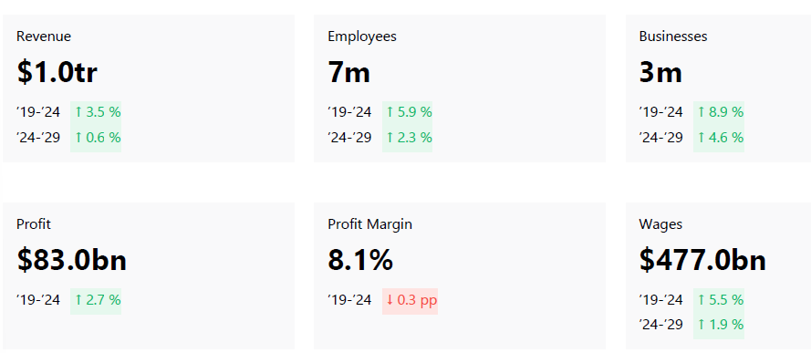
Source: IBISWorld. (Ristoff, 2024).

Figure 2: Total GMC businesses from 2011 – 2029, including a 5-year predicted forecast.
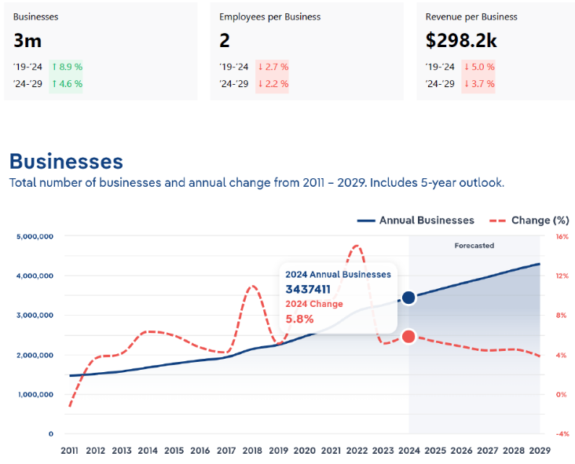
Source: IBISWorld. (Ristoff, 2024).

Figure 3: Products and Services Segmentation of Global Management Consulting.
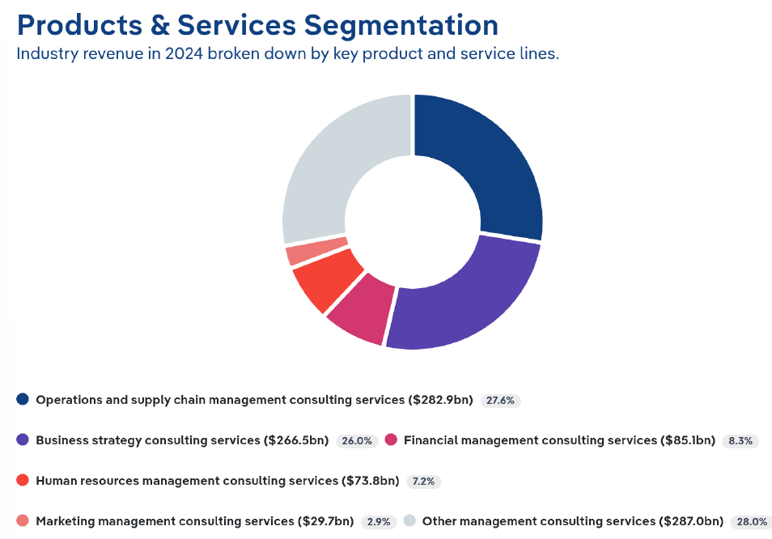
Source: IBISWorld. (Ristoff, 2024).

Figure 4: Knowledge based value-creation.
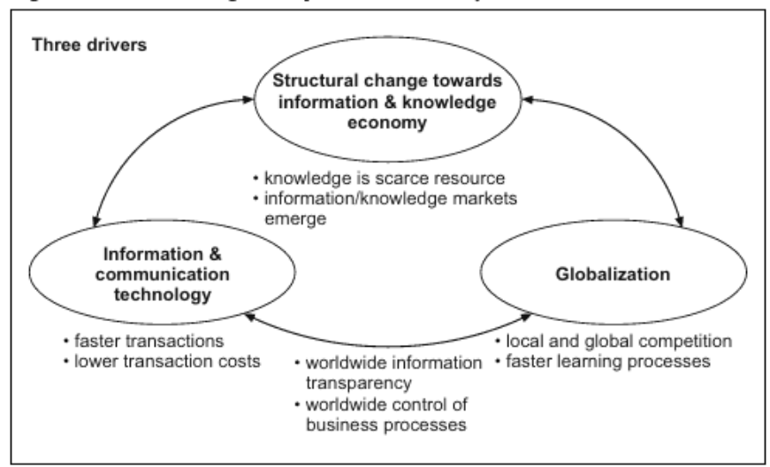
Source: Kubr (2002).

Figure 5: Theory of Planned Behaviour.
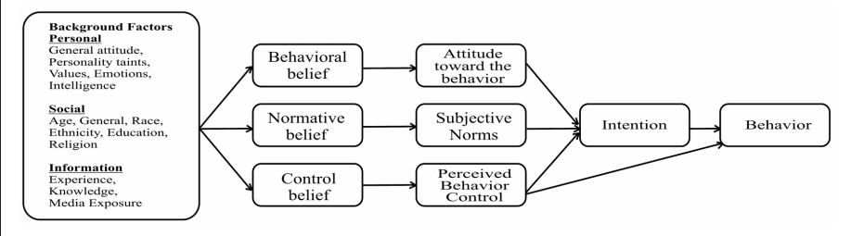
Source: Cited in Al Maskari (2018).

Figure 6: A Multi-Dimensional Model of New Venture Growth for SME’s.
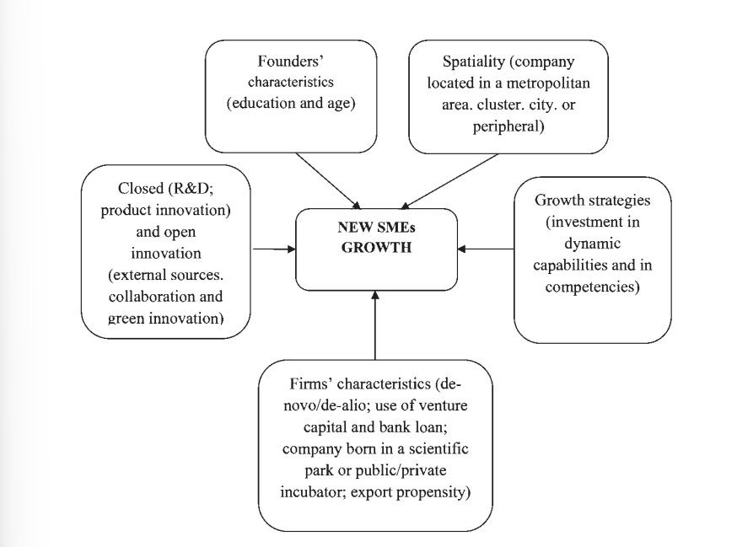
Source: Savarese et al. (2016).

Table 1: Dynamic Capabilities Framework – Capabilities
Dimensions | Description
Sensing | Refers to SME’s environmental scanning capacity,  - to learn from, and respond to external environmental changes.  - Includes identifying technological trends, market opportunities, challenges or threats.  An SME might adopt a ‘high alert’ sense to monitor innovation in AI, automation or platform orchestration, and adopt agile strategies to respond to changes.
Seizing Capability | Refer to an SME’s ability capture and capitalise on opportunities recognised from sensing activity. This involves recognising opportunities and acting on them via product innovation, market expansion, or strategic pivoting. For ModifyMe, seizing capabilities may involve adopting serverless solutions or creating a unique value proposition .
Reconfiguring Capabilities | Refer to the firms ability to adapt internal resources to align with its asset structure and operational model in response to external changes. For example, organisational restructuring, process reengineering, and technology deployment to maintain competitiveness. For ModifyMe, reconfiguring capabilities could mean adopting new technological stacks or rejigging operational flows for more efficient serverless architectures or microservives.
Learning and Integration Capabilities | This dimension reflects the importance of continuous learning and integration of new knowledge for the firms culture. It involves formalising learning from success and failure, fostering a knowledge-sharing culture and integrated acquired lessons into everyday operations. For ModifyMe, fostering a culture that values iterative trial-and-error learning from deployment and operational experiences and weaving them into service offerings would promote sustainable growth.
Source: TEECE, D. J., PISANO, G. & SHUEN, A. 1997. Dynamic capabilities and strategic management. Strategic management journal, 18, 509.

